## **Advance Tasks**

## Task: 1

Credentials of Sap Successfactor Login.

Make a login Method.

Description: Step 1 --> Enter Company Id and submit



Step 2 --> Enter Username and Enter password and login.

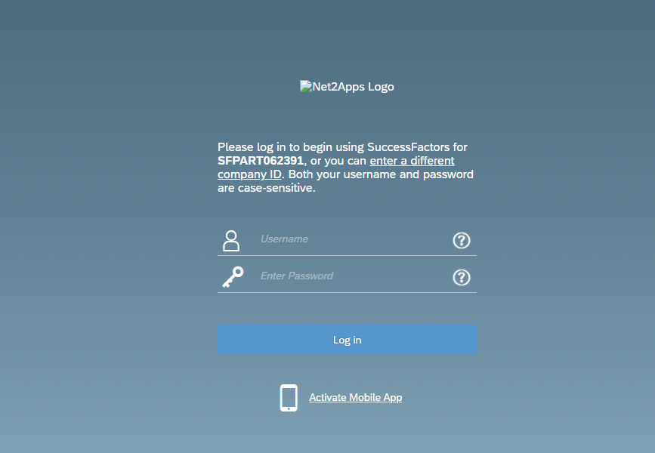

Task: 2

Get Scrub ID and Navigate to Rating Scale.

Description:

Step 1 🡪get the scrub id from url and print on console

step 2---> make the url for rating scale designer and navigate to rating scale page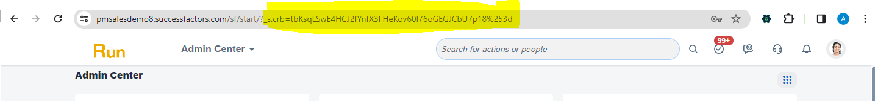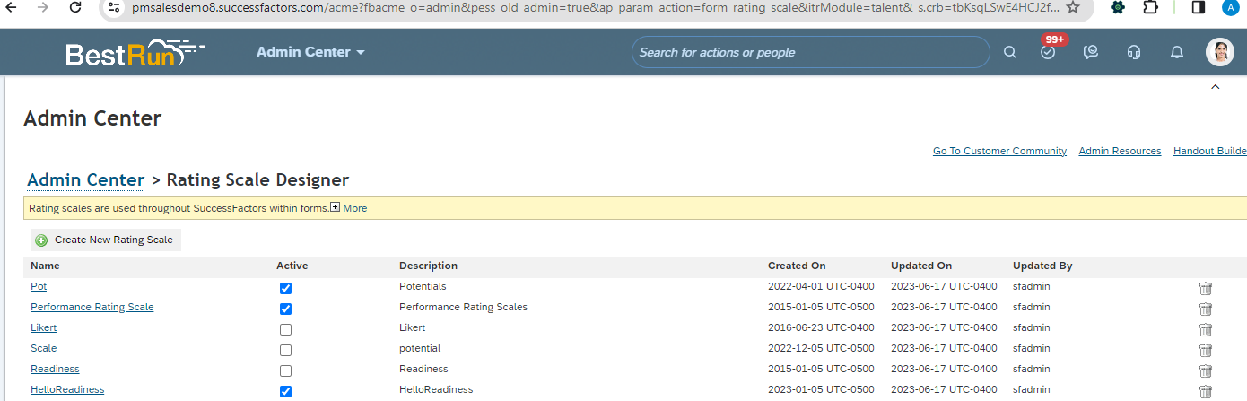

## Task: 3

Scrape Rating Scale

Description: Step 1 🡪 scrape rating scale and print on console.

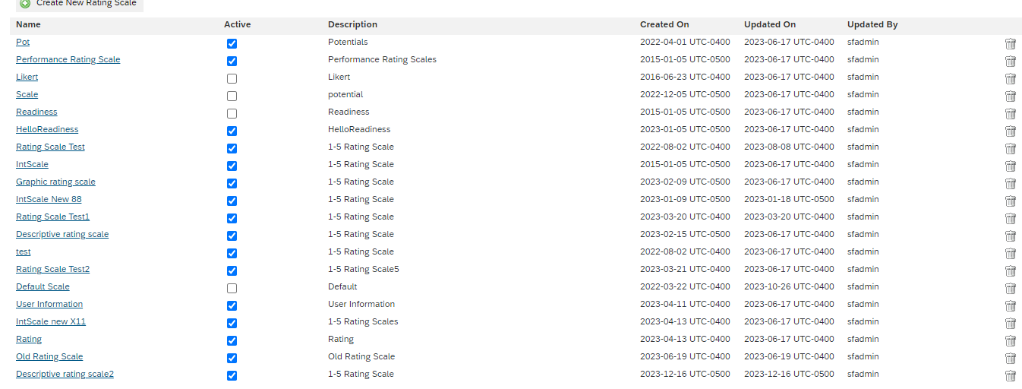

Step 2 🡪click on rating scale name and scrape them one by one

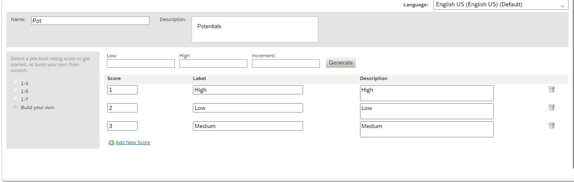

## Sample : <https://docs.google.com/spreadsheets/d/1OGTKqeWjOKY3QhtxO6C6lZJmRGqna1ptZw6ariyr5dY/edit#gid=0>

And Update Instance Record into Google Sheet.

## Task: 4

Validation of Rating Scale.

## Task: 5

Automation of Rating Scale.

Task: 6 ONB day one list Gsheet (Model & Controller).

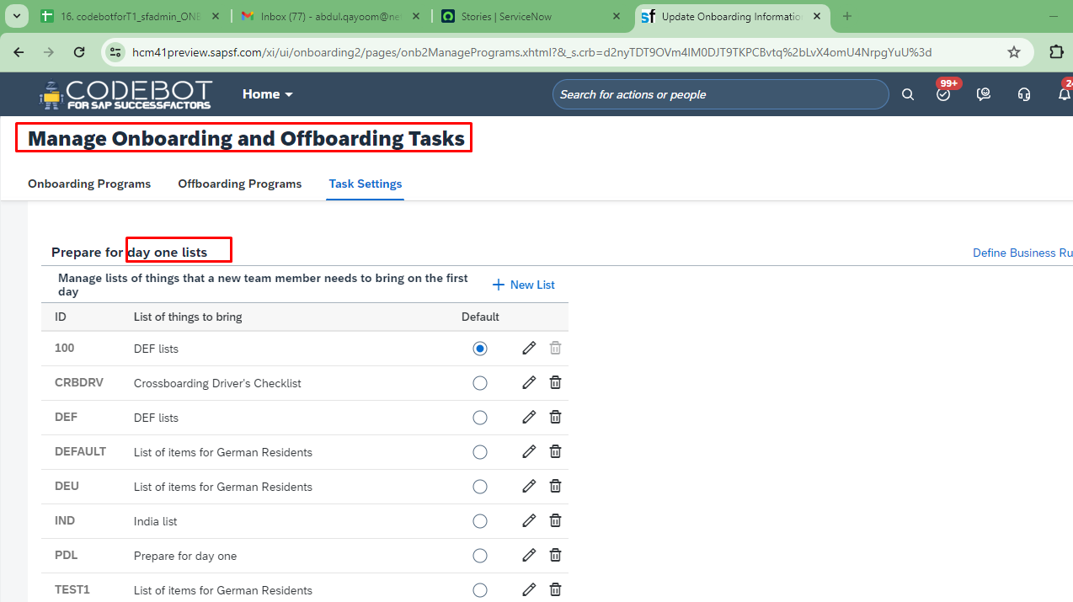

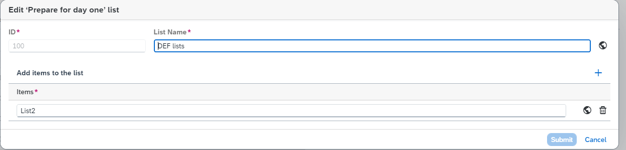

Task: 7

Scrape ONB day one list Screen.

## Task: 8

Automation ONB day one list Screen.

## Task: 9

Validation ONB day one list Screen.

Task: 10 EMP PROF Tab Elements Gsheet (Model & Controller).

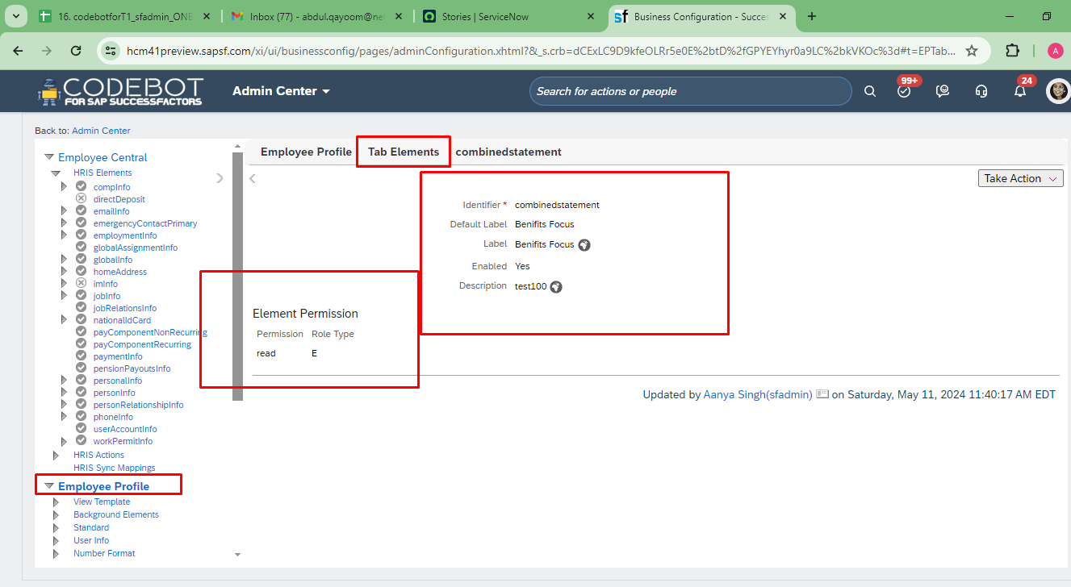

Task: 11

Scrape EMP PROF Tab Elements screen.

## Task: 12

Automation EMP PROF Tab Elements screen.

## Task: 13

Validation EMP PROF Tab Elements screen.

Task: 14 Alert Message Gsheet (Model & Controller).

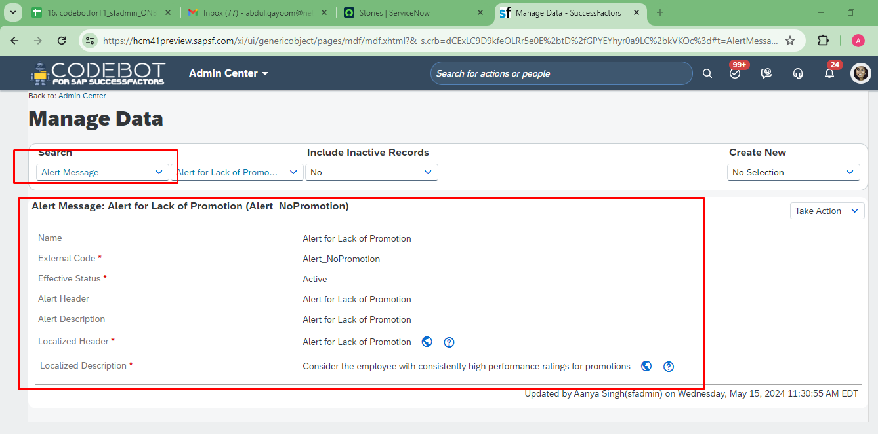

Task: 15

Scrape Alert Message screen using ODATA API.

Sap Successfactor Credentials

# Global.HOST_ADDRESS = "https://pmsalesdemo8.successfactors.com"

# Global.COMPANY_ID = "SFPART062391"

# Global.USER_NAME = "sfadmin"

# Global.PASSWORD = partBos@DC8@